Denny Coffman
  - Representing the 6th House District – North Kona, Keauhou, Kailua-Kona and Honokohau
SECOND edition | MARCH 2011
State's Budget Picture: One Step Forward – Two Steps Backwards
Working on Capital Improvement funding for:
- The new Kona Judiciary Complex,
- Repairs at the Kona Community Hospital,
- Site planning for a new school campus on state land for West Hawaii Exploratory Academy.
Legislative tracking and follow-up on:
- Phase II of the Queen Ka‘ahumanu Highway widening project
- Build-out of the West Hawaii Community College

I was hoping that our fiscal picture would be better heading into our budget planning for 2012 and 2013. The reality is that our current year's financial plan is in trouble.

It appears that we need to find something approaching $200 million to balance our FY11 budget that ends on June 30, 2011. We will need an additional $1 billion to balance our next two fiscal years, FY12 and FY13.

The Governor put several revenue issues on the table. Many have been dropped by either the House and/or Senate. The remainder have been modified and most will produce fewer dollars than requested.

The budget developed by the House Finance Committee passed a number of bills to increase revenues by over $1 billion over the next two years. In addition the House reduced operating expenses in almost every government department. The biggest being: Education $55 million, Higher Education $16 million, Human Services $22 million and Health Services $17.8 million.

The House budget and revenue bills are now being processed by the Senate. In a few weeks negotiations between the House and Senate will begin. The Senate is still talking about raising the general excise tax. The House wants to look at other options. Stay tuned.

Denny
District 6
2011 Focus

Photo Journal
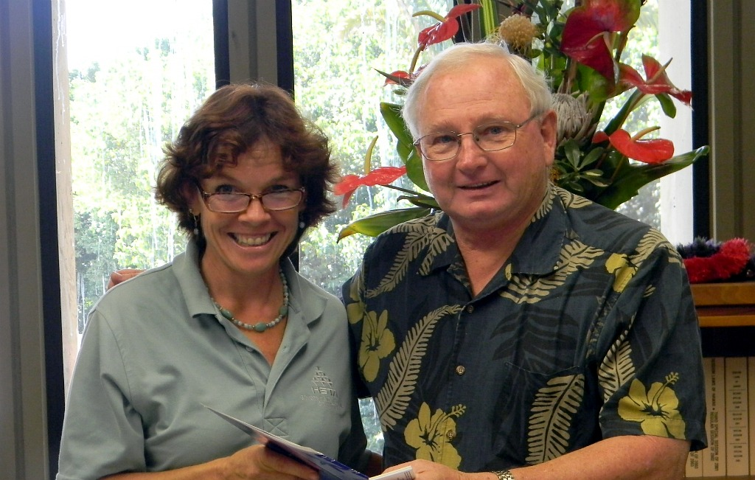
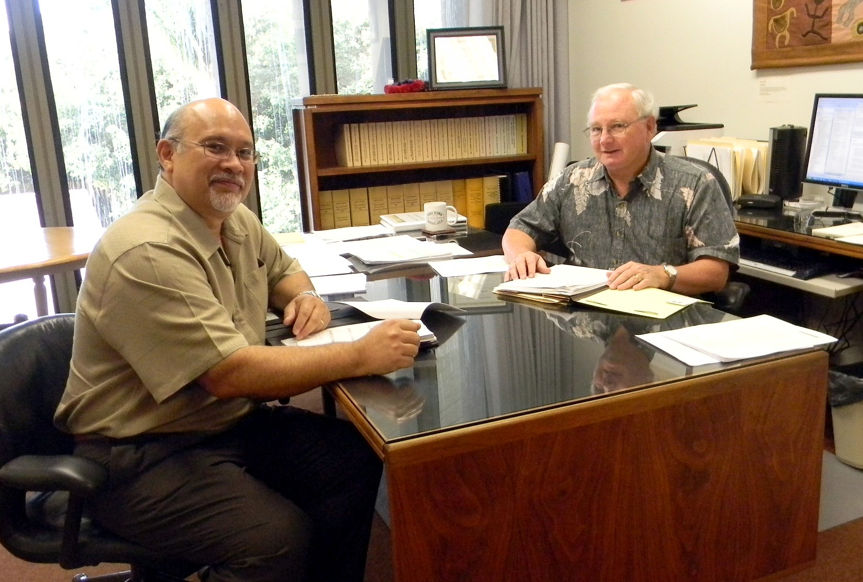
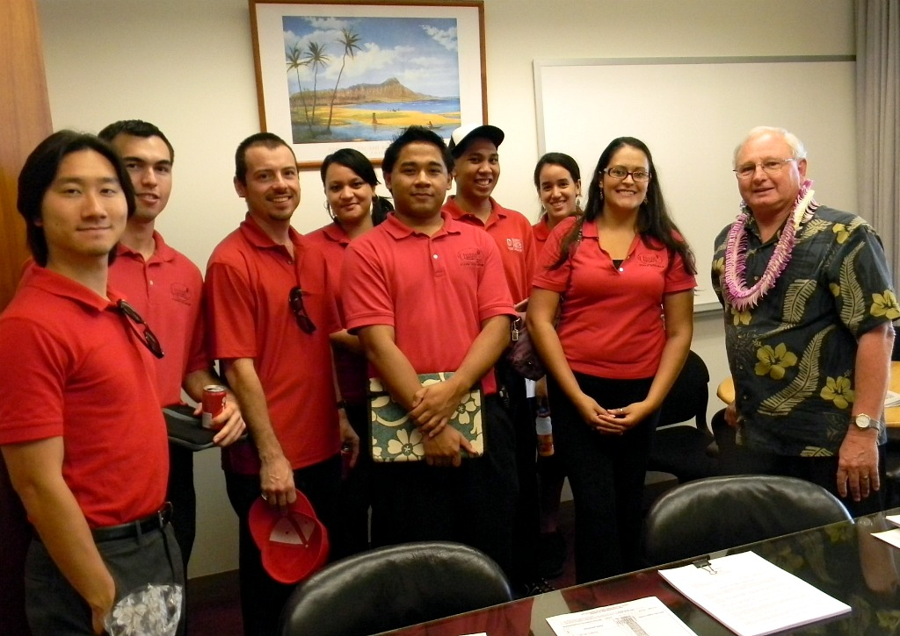
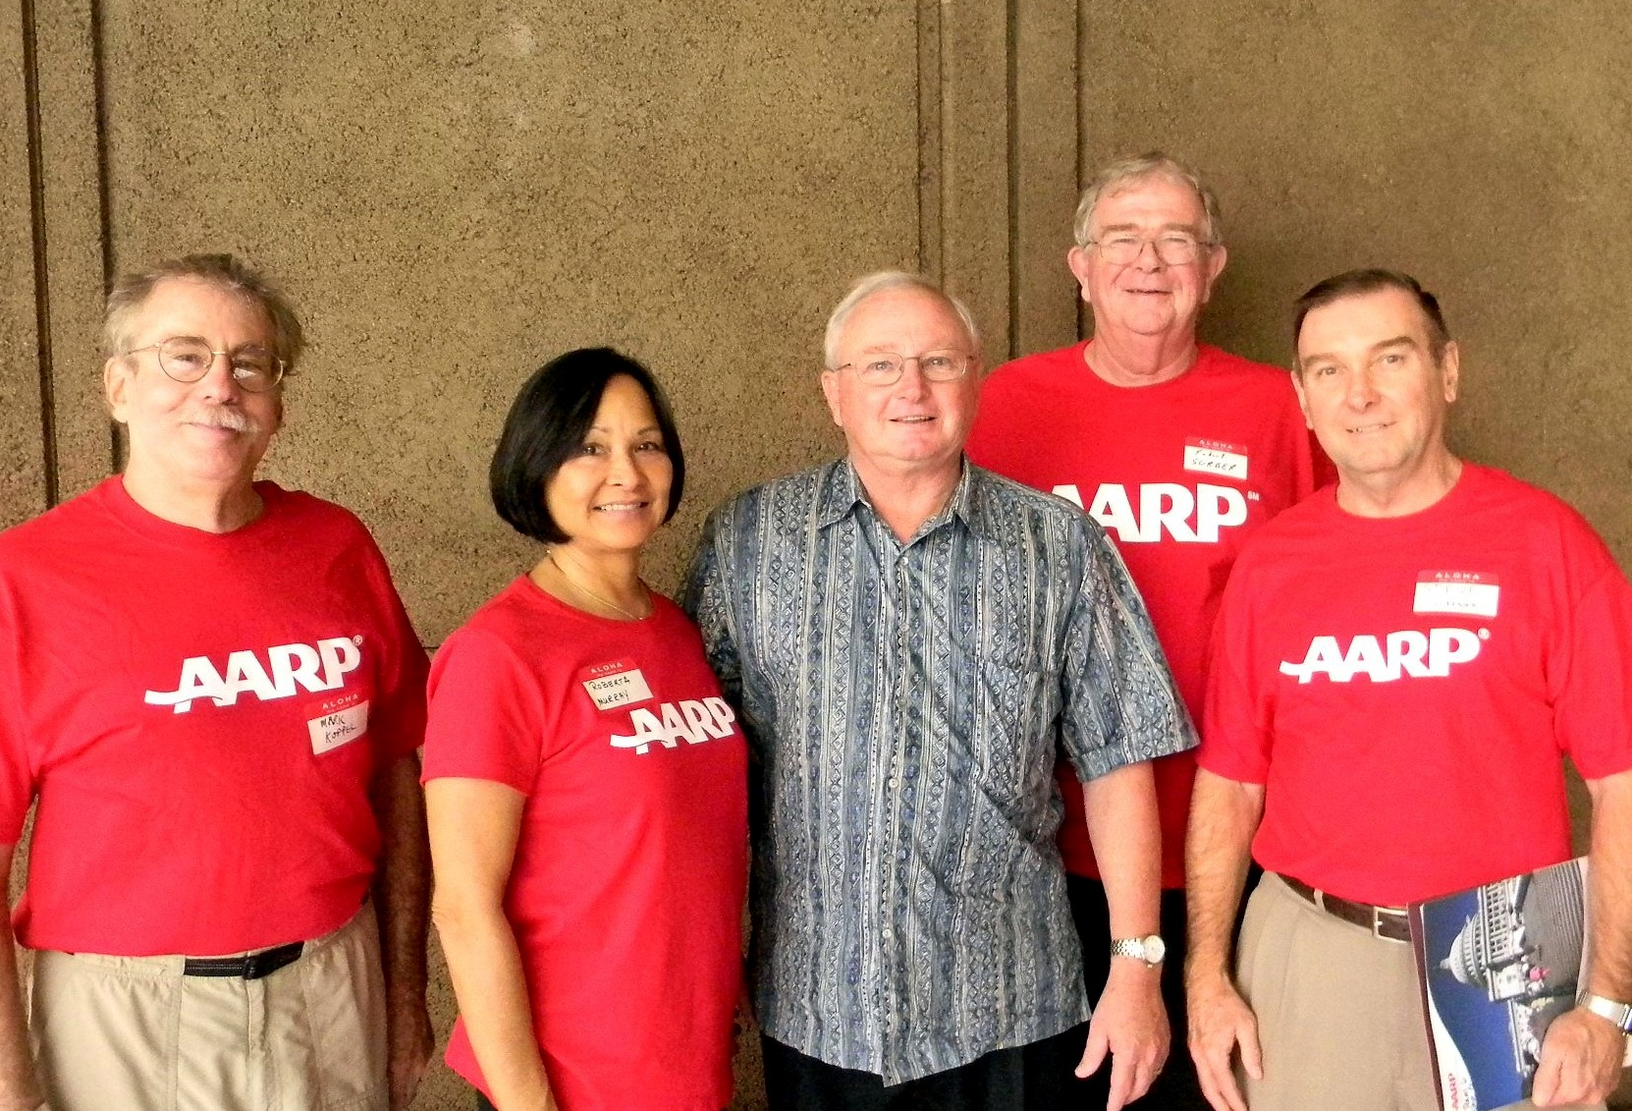
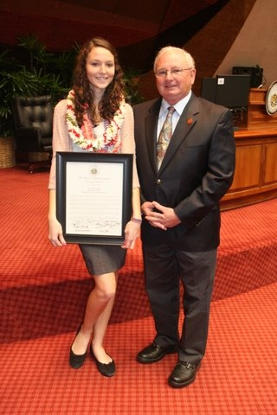

Clockwise from top left: meeting with students from UH Hilo on opening day; AARP members from District 6 meeting the Rep. before session; 2011 Prudential Award Honoree Natalie Mohr from Kealakehe High School; meeting with Rod Maile, Administrative Director of the Judiciary; meeting with members of the HSTA from District 6.

Contact Us
If you want to receive this newsletter via email, please send an email to miura@capitol.hawaii.gov, subject "SUBSCRIBE."
- Email: repcoffman@capitol.hawaii.gov
- Phone: 808-586-9605
- Fax: 808-586-9608

