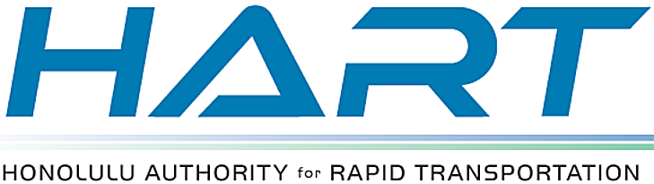

HART WEEKLY eBLAST | AUGUST 1, 2014

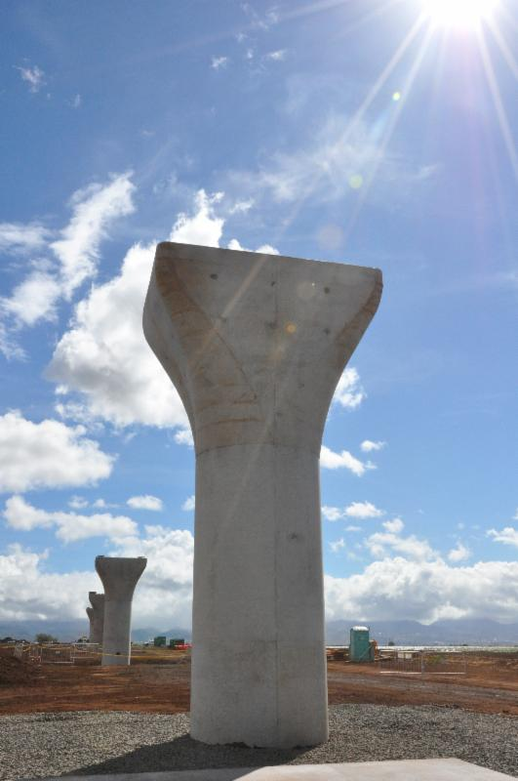
RAIL COLUMN WORK MOVES TO WAIPAHU

Column construction for the elevated rail guideway is moving forward in east Kapolei and Ewa, and construction crews are now scheduled to begin similar work in the Waipahu area this month.

Construction is rolling along with more than 115 concrete columns completed from Kualakai Parkway in east Kapolei to Farrington Highway in Ewa just past Fort Weaver Road.

Crews are now stationed along Farrington Highway on the west end of Waipahu conducting drill work in preparation for underground shafts to support the columns.

Much of the Waipahu column work in the coming months will take place along the medians of Farrington Highway during non-peak commuting times and at night. The contractor is required to keep open at least one lane of Farrington Highway in each direction during the work.

As major rail construction now shifts into residential and commercial areas, HART and Kiewit ask residents, business owners and drivers for their patience and understanding while driving through construction work zones.
Monthly construction update meetings are held for the community and businesses in Waipahu and Aiea areas. The next Waipahu meeting will be on Wednesday, August 13 at 6 p.m. at the Waipahu High School Library. The next Aiea meeting will be Tuesday, August 5 at 6 p.m. at the Pearl Ridge Elementary School cafeteria.

If your business organization or community group would like a project update tailored to your area, or if you have general questions, contact our 24-hour project hotline at 566-2299. You can also get the latest construction updates at our website at www.HonoluluTransit.org.

